ABSTRACT GUIDELINES
FOR THE Grand RENEWABLE ENERGY 2022
John. Schubert¹ and David. Kato²
¹Makuhari Institute
²National Institute of Advanced Industrial Science and Technology,
SUMMARY: This template file provides essential information on how to prepare and submit Abstract to the Grand RENEWABLE ENERGY 2022. Please follow them as precisely as possible. The deadline of the submission of the abstract is within two weeks after registration complete. Abstracts are specified to two (2) A4-pages and 2 MB max in a file size regardless of oral or poster presentation. The title is in bold capital letters and centered at the top of the first page. It must be followed by the author(s) name(s), organization(s). Leave one bank line between the title and the name of the author(s). When several authors prepare a paper, the name of the presenter should be underlined. The name of each one’s organization should be easily distinguished. Type a summary of your abstract in less than 10 lines, followed by the keywords up to 5 words.
Keywords(up to 5 words): renewable energy, solar energy, wind power, manuscript, paper size

INTRODUCTION
In order to complete your abstract, replace all parts of this text with your presentation without changing any layout (font type and size, line spacing, page margins and so on). DO NOT insert page numbers or page headers/footers. Papers not meeting these guidelines may be excluded from the conference abstracts. These instructions have been formatted in the manner in which you should prepare your manuscript, thus you may use this document as an example.
The manuscripts are to be formatted using A4-size paper (210 mm x 297 mm), single-spaced except for headings and subheadings. The preferred font of text is Times New Roman -10 point (shown here), or as close a match as possible. Full justification should be used when available. Bold should be used for the paper title and major headings. Use a two-column format as this template except title, author(s), affiliation(s), summary, and keyword(s). Each column is 80 mm wide with spacing of 10 mm between columns (total width is 170 mm). All the margins are to be 25 mm including the title page.
SUBMISSION AND NOTIFICATION OF ABSTRACT
Deadline of Abstract
You should submit your abstract on the conference web site (http://www.grand-re2022.org) within the two weeks after the registration complete.. Late submission is not permitted.

Review and Notification
The submitted abstracts will be reviewed by the Program Committee, and then the corresponding author will be advised when the paper is not fitted with the principle of this conference,

PREPARATION OF MANUSCRIPT
Manuscript length and volume limits
Abstracts are specified to two (2) A4-pages (including all figures) and 2 MB in a file size.

Title block
The title should appear in BOLD CAPITAL LETTERS with 12 pt. of Times New Roman centered across both columns without underlining. Type the author’s name and affiliation in upper and lower case letters, centered and double-spaced below the title. For multiple organizations, use superscripted numbers to identify organization and list the organizations after the author list.

Headings
Major captions (headings) are to be in capitals without underlining, centered over one column and bold. Subheadings should start at the left-hand margin on separate lines. A blank line space should be placed both before and after each heading or subheading. There should be no blank line after the title of the sections. Sub caption begins with the upper case. If you use sub-sub captions, please type it with normal plain letters. The fonts of text should be Times New Roman of 10 pt. in size with single line spacing. At the beginning of each paragraph please indent as on this document.

Equations
Equations are to be numbered consecutively throughout the paper. The equation number, in parentheses, should be placed flush with the right-hand margin of the column. When possible, use an equation editor.
$E={\text{mc}}^{2}$ (1)

Leave a blank line before and after equations.

References
References are to be listed and numbered at the end of the paper with a left-justified format. The text which refers the references should show them as [1]. Titles of journals and books should be written in Italic script. If italic script is not available, titles may be bold. Volume numbers in references should be typed in bold. A blank line should be used to separate references in lists as follows:

[1] R. Renewer et al., “How to rearrange - - - - - - - -”, Applied Physics Letters. 83, 2002, pp.234-238.

[2] D. Hadni and A. Yamada, “Relationship between - - - - - -”, Proceedings of 8th international Conference on - - - - - - - - -, 2001, pp. 1552-1562.

Illustrations and graphics
Hand-written lettering on figures is not acceptable. The use of color in figures and photos is recommended but please keep in mind that total file size never exceeds 2 MB.
Figures and tables should be identified by Arabic numerals and positioned within the text. Illustrations and graphics may be one- or two-columns wide and should include captions or titles.


Figure 1. The Grand RENEWABLE ENERGY.

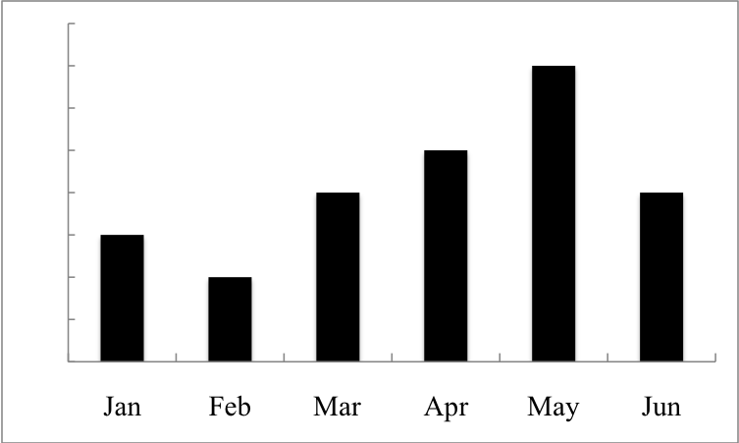
Figure 2. Solar energy irradiation

Table 1. Latitudes of big cities.
 | Tokyo | New York | Paris | Singapore
Latitude (deg.) | 35.69 | 40.78 | 48.73 | 1.37

When possible, use a table editor or tabs to create tables. Please do not use spaces to align the columns of your table. Also, do not use the “columns” feature to create tables. If possible, the table data should be centered within a single column. If there is not enough space left on the page to allow for your table, end your page and continue on the next page.
COPYRIGHT
The copyright of Abstracts and Proceedings belongs to the authors. The Grand RE2022 Organizing Committee has a right to publish Abstract books and proceedings for this conference.
ABSTRACT DELIVERY
All accepted abstracts will be displayed to the conference web site (http://www.grand-re2022.org) and can be observed or loaded down only for those completing the registration. Abstract observation and download are possible through the PC.
FINAL NOTES
Correction of the abstract after submission
Correction of papers after submission is possible. An update abstract is loaded to our web site.
ACKNOWLEDGMENT
Thank you for submitting your abstract. We are eagerly looking forward to seeing all of you at the conference.

Note that those who want to submit to J-Stage are required to submit four-page full paper based on this abstract, regardless of oral or poster presentation by the end of conference finish, December 20, 2022. Format is same as mentioned in ABSTRACT.

